

**Department of Information and Communication Technology Faculty of Technology**

**University of Ruhuna**

**Database Management Systems ICT 1222**

**Assignment 02**

Group 10

Submitted to: Mr.P.H.P. Nuwan Laksiri

Submitted by: TG/2021/1010 L.S.R. VIDANAARACHCHI

* **Introduction about the problem/group project**

Faculty of Technology, University of Ruhuna, Learning Management System contains many features that explain many functionalities for a university LMS. This project is based upon that LMS system and aims to manifest a replica of the back-end database of the FoT LMS.

The main concerns for a LMS is to manage student data. That main concern can be categorized into even more sub concerns.

1. Should be able to manage all academic and non-academic personal data separately.
2. Should be able to handle course data and related student data.
3. Should be able to manage academic documents.
4. Should be able to handle attendance data.
5. Should be able to manage and handle different submissions separately.
6. One administrator should be able to manage the entire database.
7. A hierarchy of privileges to manage and access the database is crucial.

* **Brief introduction to the solution**

The solution that was developed to meet the requirements mentioned above fulfills those requirements by providing,

1. Separate student related data tables and staff related data tables to manage data separately.
2. Different course tables to separate information for more clarity.
3. Different forms of academic assessments are given different tables with separate tables for results.
4. A past paper table for managing past paper separately from other academic documents.
5. Due to implementing a separate attendance table allows to log all attendance for different courses.
6. Assement table for marking academic sessions and labsheet table for non-marking academic sessions.
7. Different procedure based view systems to enhance security and understandability of the solution.

* **Proposed ER/EER diagram**

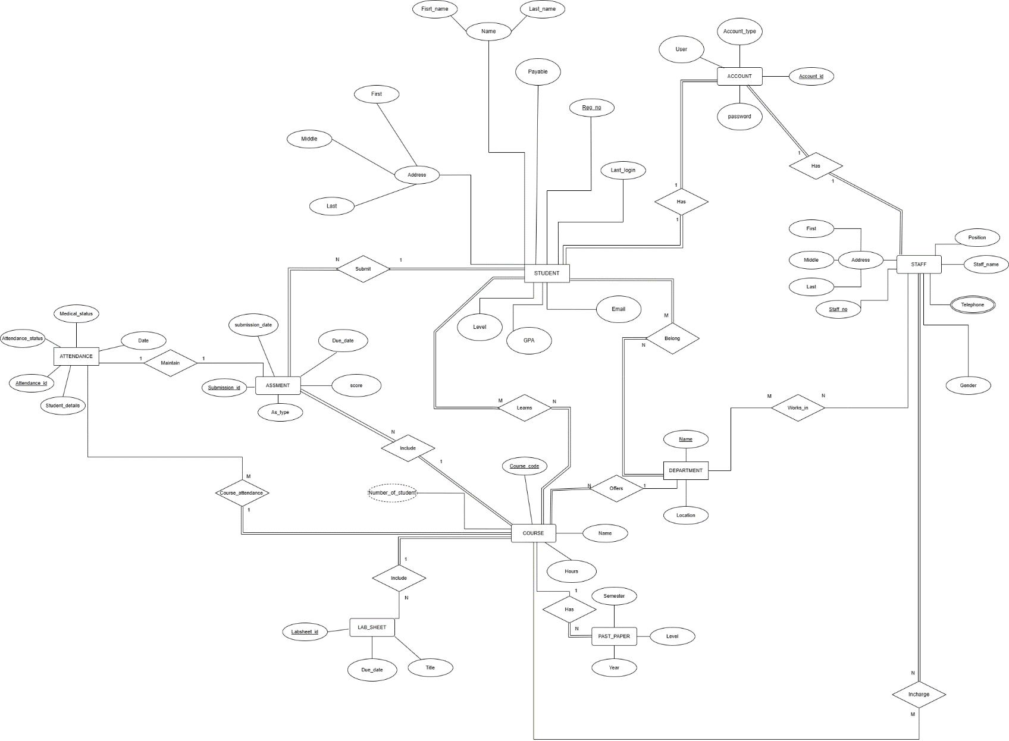

* **Proposed Relational mapping diagram**

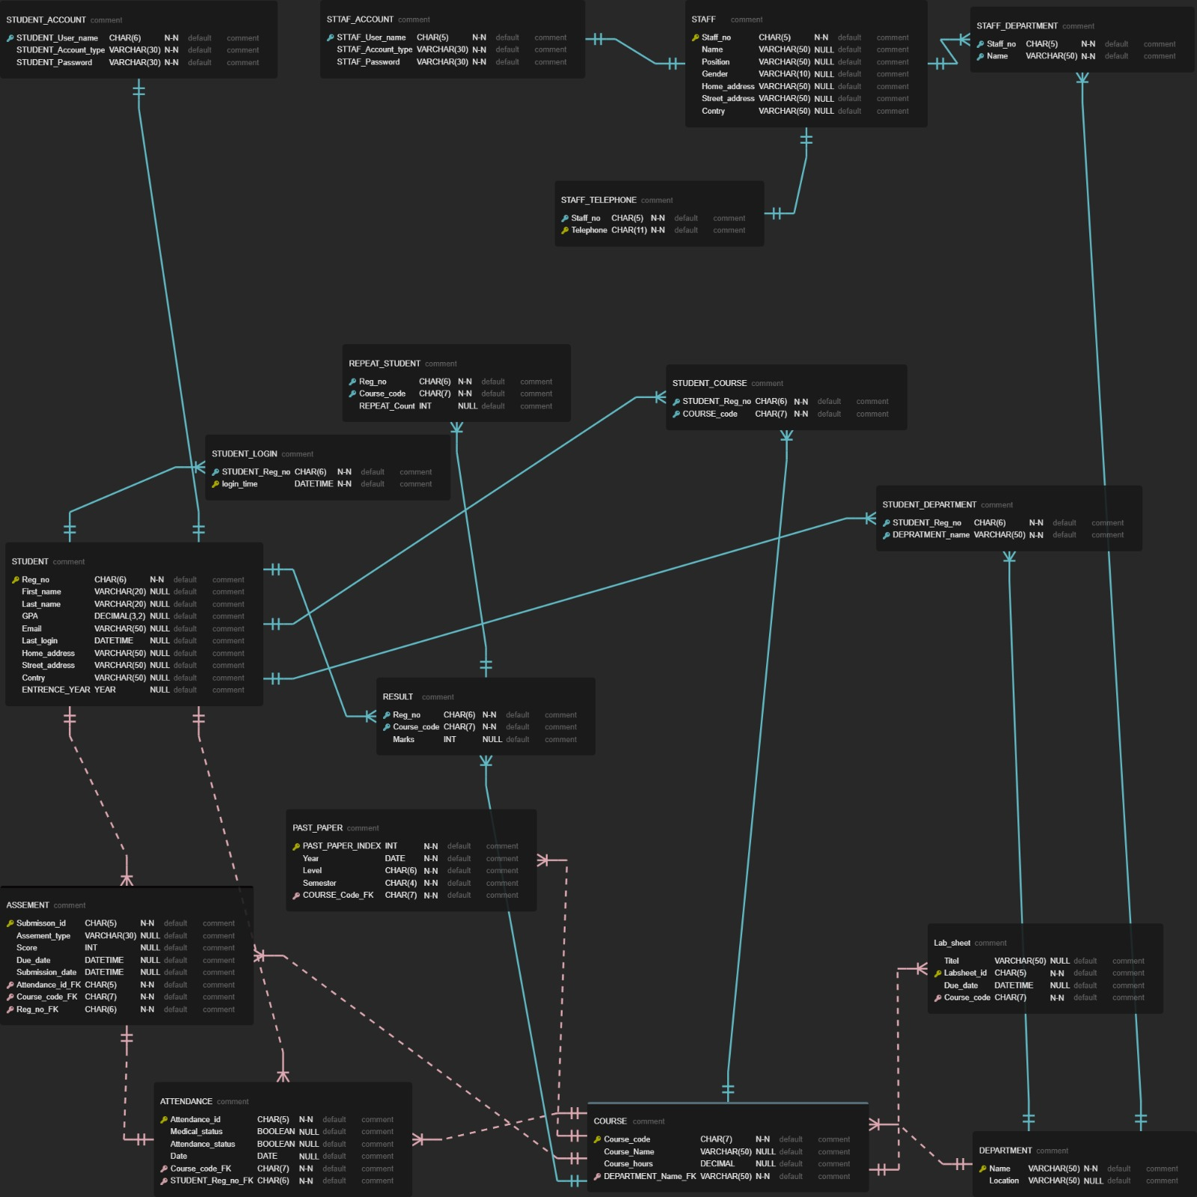

* **Table structure the solution**

1. **STUDENT** tableis acts as central hub to many tables such as **STUDENT_ACCOUNT, STUDENT_LOGIN, REPEAT_STUDENT, STUDENT_COURSE, STUDENT_DEPARTMENT, COURSE** and **REPEAT_STUDENT** which contains different data but tables are connected together.
2. **DEPARTMENT** table is also connected to tables such as **STUDENT_DEPARTMENT, STAFF_DEPARTMENT.**
3. **STAFF** table holds strings to **STAFF_ACCOUNT, STAFF_DEPARTMENT** and **STAFF_TELEPHONE** tables.
4. **COURSE** table connects to **RESULT** table as well as **STUDENT_COURSE** table.
5. **ASSEMENT, ATTENDANCE,** and **PAST_PAPER** tables connects to many tables because data within those tables corresponds many data.
6. As for internal table structure regarding data types are used for data to be consistent.

* **Architecture of the solution**

1. **Database Management System –** A DBMS software is used to implement and maintain this database.
2. **Tables** – Tables are the most important part of the architecture which holds all data.
3. **Views** – Views are used to encapsulate data to prevent unnecessary data leaks.

* **Tools and technologies that were used**

1. DrawIO online tool – To draw ER diagram.
2. ERD EDITOR Visual Studio Code extention – To draw the relational schema.
3. Microsoft Word – To create the SRS report and the final report.
4. Microsoft Teams – Using video conferencing technology to create the database coordinating with each other.
5. XAMPP with MYSQL – To develop the database this API was used.
6. GitHub – Acts as a portfolio to show the progress route of the database development.

* **Security measures that have taken to protect your DB**

Mainly creating different users with different access levels are used to give security to the database. **Least privilege principle** is thoroughly followed to maximize the security for the database.

* **Brief description about DB Accounts/Users and the reasons for creating such Accounts/Users**

1. **Admin –** This user account is the only person with each and every access method to the database and the only person that can give others access privileges to the database.
2. **Dean –** This user has the same privileges as the Adminbut cannot give other privilege access to the database. It’s not considered in the standard operating procedures for the Dean to act as the distributor of privileges while an Admin user is present.
3. **Lecturer –** Lecturer only requires the privilege to concern himself with academic data manipulation so no need to create users or other administrator level functionalities.
4. **Technical Officer –** The job of a technical officer is to manage attendance details so in order to increase data security and ease the job of user in subject only access to attendance related tables are given.
5. **Student –** Student only requires to access academic related data and to find out whether the student is eligible for the final examination and the final results of the examination, thus tables such as attendance, lab sheets and some derived views of marks and results are required.

* **Code snippets to support your work**

This section contains tools that were developed within the database to assist the users to query data more effectively and efficiently. While stored procedures simplifies querying and views eases understanding and encapsulates data.

**Stored procedures**

**TG1010**

/////////////////// To Get Course This Student Enrollment /////////////////////

DELIMITER //

CREATE PROCEDURE GetStudentCourses(IN studentRegNo CHAR(6))

BEGIN

SELECT c.course_code, c.name

FROM Student_Course sc

JOIN course c ON sc.COURSE_code = c.course_code

WHERE sc.STUDENT_Reg_no = studentRegNo;

END //

DELIMITER ;

/////////////// To get Upcoming Labsheet for This Student ///////////

DELIMITER //

CREATE PROCEDURE StudentUpcomeLab (IN studentRegNo CHAR(6))

BEGIN

SELECT ls.labsheet_id, ls.title, ls.due_date

FROM Student_Course sc

JOIN labsheet ls ON sc.COURSE_code = ls.course_code

WHERE sc.STUDENT_Reg_no = studentRegNo AND ls.due_date > NOW();

END //

DELIMITER ;

/////////////// To get Previous Labsheet for This Student ///////////

DELIMITER //

CREATE PROCEDURE StudentPreLab (IN studentRegNo CHAR(6))

BEGIN

SELECT ls.labsheet_id, ls.title, ls.due_date

FROM Student_Course sc

JOIN labsheet ls ON sc.COURSE_code = ls.course_code

WHERE sc.STUDENT_Reg_no = studentRegNo AND ls.due_date < NOW();

END //

DELIMITER ;

///////////////// To add Labsheet as Lecture ////////////////////

DELIMITER //

CREATE PROCEDURE AddLabSheet(

IN labsheet_id CHAR(9),

IN title VARCHAR(255),

IN due_date DATETIME,

IN course_code CHAR(7)

)

BEGIN

INSERT INTO labsheet (labsheet_id, title, due_date, course_code)

VALUES (labsheet_id, title, due_date, course_code);

END //

DELIMITER ;

CALL AddLabSheet('ICT424310', 'TEST Lab Sheet', '2023-12-31 14:00:00', 'ICT4243');

///////////////// To add Past Papers as Lecture ////////////////////

DELIMITER //

CREATE PROCEDURE AddPastpapers(

IN paper_title VARCHAR(255),

IN year YEAR,

IN level CHAR(6),

IN semester CHAR(4),

IN course_code CHAR(7)

)

BEGIN

INSERT INTO Past_Papers (paper_title, year, level, semester, course_code)

VALUES (paper_title, year, level, semester, course_code );

END //

DELIMITER ;

CALL AddPastPapers ('TEST Paper 1', 2022, 'level4', 'sem1', 'ICT4243');

**TG1030**

01. Procedure to change department name and the course code for a given student tg number.

DELIMITER //

CREATE PROCEDURE updateacademics(IN Reg_No CHAR(5), IN dep_name VARCHAR(10), IN course_code CHAR(7))

BEGIN

UPDATE student_department SET DEPARTMENT_name=dep_name WHERE STUDENT_Reg_no=Reg_NO;

UPDATE student_course SET COURSE_code=course_code WHERE STUDENT_Reg_no = Reg_No;

END//

DELIMITER ;

CALL updateacademics("TG0200", "ICT", "ICR4243");

02. Procedure to insert a student record

DELIMITER //

CREATE PROCEDURE insertstudent(IN Reg_no CHAR(6), IN First_name VARCHAR(25), IN Last_name VARCHAR(25),IN Email VARCHAR(30),IN Home_address VARCHAR(30),IN Street_address VARCHAR(50), IN Country VARCHAR(25))

BEGIN

SELECT 'Example format- ('TG9999', 'First_name', 'Last_name', 'person@gmail.com', 'No99', 'Province/city - Road name', 'Country name');' As 'Format';

INSERT INTO student(Reg_no, First_name, Last_name, Email, Home_address, Street_address, country)

VALUES(Reg_no, First_name, Last_name, Email, Home_address, Street_address, country);

UPDATE Student

SET Entrance_year = '2018'

WHERE Reg_No BETWEEN 'TG0200' AND 'TG0399'

ORDER BY Reg_No ASC;

UPDATE Student

SET Entrance_year = '2019'

WHERE Reg_No BETWEEN 'TG0400' AND 'TG0599'

ORDER BY Reg_No ASC;

UPDATE Student

SET Entrance_year = '2020'

WHERE Reg_No BETWEEN 'TG0600' AND 'TG0999'

ORDER BY Reg_No ASC;

UPDATE Student

SET Entrance_year = '2021'

WHERE Reg_No BETWEEN 'TG1000' AND 'TG1200'

ORDER BY Reg_No ASC;

END//

DELIMITER ;

CALL insertStudent('TG1067', 'Tharindu', 'Sithum', 'TharidSitu88@example.com', '123 Main St', 'Mathale - Temple Road', 'Sri Lanka');

03. A procedure to select students for a given street address

DELIMITER //

CREATE PROCEDURE stud_place(IN province_name VARCHAR(15))

BEGIN

SELECT 'Enter a city or a province starting from capital letters' AS 'Instructions';

SELECT Reg_no As 'Student Register Number', First_name AS 'Student First Name', Last_name AS 'Student Last name'

FROM Student

WHERE Street_address LIKE province_name;

END//

DELIMITER ;

CALL stud_place('Piliyandala');

04. Select the count of students for a given department

DELIMITER //

CREATE PROCEDURE stud_count(IN Dep_name VARCHAR(3))

BEGIN

SELECT COUNT(STUDENT_Reg_no) AS 'Number of Students over all levels within that department'

FROM Student_department

WHERE DEPARTMENT_name = Dep_name;

END//

DELIMITER ;

CALL stud_count('ICT');

05. Select the tg numbers of students for a given course module

DELIMITER //

CREATE PROCEDURE enrol_stud(IN course_code VARCHAR(7))

BEGIN

SELECT STUDENT_Reg_no AS 'Students enrolled to the given course'

FROM student_course

WHERE COURSE_code = course_code;

END//

DELIMITER ;

CALL enrol_stud('ICT4123');

06. Procedure to enter a course credit value

DELIMITER //

CREATE PROCEDURE Credit()

BEGIN

ALTER TABLE course ADD COLUMN Credits INT;

UPDATE course

SET Credits = CASE

WHEN course_code = 'BST1113' THEN 1

WHEN course_code = 'BST1222' THEN 2

WHEN course_code = 'BST2113' THEN 3

WHEN course_code = 'BST2213' THEN 4

WHEN course_code = 'BST3133' THEN 1

WHEN course_code = 'BST3222' THEN 2

WHEN course_code = 'BST4113' THEN 3

WHEN course_code = 'BST4222' THEN 4

WHEN course_code = 'ENG1212' THEN 1

WHEN course_code = 'ET1112' THEN 2

WHEN course_code = 'ET1223' THEN 3

WHEN course_code = 'ET2122' THEN 4

WHEN course_code = 'ET2243' THEN 1

WHEN course_code = 'ET3112' THEN 2

WHEN course_code = 'ET3222' THEN 3

WHEN course_code = 'ET4114' THEN 4

WHEN course_code = 'ET4242' THEN 1

WHEN course_code = 'ICT1112' THEN 2

WHEN course_code = 'ICT1123' THEN 3

WHEN course_code = 'ICT1242' THEN 4

WHEN course_code = 'ICT1243' THEN 1

WHEN course_code = 'ICT1244' THEN 2

WHEN course_code = 'ICT1245' THEN 3

WHEN course_code = 'ICT1246' THEN 4

WHEN course_code = 'ICT1247' THEN 1

WHEN course_code = 'ICT2112' THEN 2

WHEN course_code = 'ICT2223' THEN 3

WHEN course_code = 'ICT3112' THEN 4

WHEN course_code = 'ICT3234' THEN 1

WHEN course_code = 'ICT4123' THEN 2

WHEN course_code = 'ICT4243' THEN 3

ELSE 4

END;

END //

DELIMITER ;

CALL Credit();

07. Add Grade Point Value Column

DELIMITER //

CREATE PROCEDURE Gpv()

BEGIN

ALTER TABLE result ADD GPV_Value DECIMAL(3, 1);

UPDATE result SET GPV_Value = ROUND(0.1 + (RAND() * 3.8), 1);

END//

DELIMITER ;

CALL Gpv();

**TG1038**

DELIMITER $$

CREATE PROCEDURE `find_Result_of_a_course` (IN Course_code char(7))

BEGIN

SELECT * FROM result_details r WHERE r.Course_code= Course_code ;

END $$

DELIMITER ;

DELIMITER $$

CREATE PROCEDURE `find_Result_of_a_student` (IN STUDENT_Reg_no char(6))

BEGIN

SELECT * FROM result_details r

WHERE r.STUDENT_Reg_no = STUDENT_Reg_no ;

END $$

DELIMITER ;

DELIMITER $$

CREATE PROCEDURE `find_Result_of_student_course` (IN STUDENT_Reg_no char(6),IN Course_code char(7))

BEGIN

SELECT * FROM result_details r

WHERE r.STUDENT_Reg_no = STUDENT_Reg_no AND r.Course_code= Course_code ;

END $$

DELIMITER ;

DELIMITER $$

CREATE PROCEDURE `find_attendance_for_a_batch`(IN batch INT)

BEGIN

SELECT a.*

FROM attendence_detalis a

JOIN student s ON s.Entrance_year = batch AND s.Reg_no = a.STUDENT_Reg_no;

END$$

DELIMITER ;

DELIMITER $$

CREATE PROCEDURE `find_attendence_of_a_student` (IN STUDENT_Reg_no char(6))

BEGIN

SELECT * FROM attendence_detalis a

WHERE a.STUDENT_Reg_no = STUDENT_Reg_no ;

END $$

DELIMITER ;

DELIMITER $$

CREATE PROCEDURE `CA_DETAILS_of_a_COURSE` (IN Course_code char(7))

BEGIN

select * FROM ca_eligibility c where c.Course_code = Course_code;

END $$

DELIMITER ;

DELIMITER $$

CREATE PROCEDURE `CA_DETAILS_of_a_Course_for_STUDENT` (IN STUDENT_Reg_no char(6),IN Course_code char(7))

BEGIN

select * FROM ca_eligibility c

where c.Course_code = Course_code AND c.STUDENT_Reg_no = STUDENT_Reg_no ;

END $$

DELIMITER ;

DELIMITER $$

CREATE PROCEDURE `CA_DETAILS_of_a__STUDENT` (IN STUDENT_Reg_no char(6))

BEGIN

select * FROM ca_eligibility c

where c.STUDENT_Reg_no = STUDENT_Reg_no ;

END $$

DELIMITER ;

DELIMITER $$

CREATE PROCEDURE `CA_DETAILS_of_a__batch` (IN batch INT(4))

BEGIN

SELECT c.* FROM ca_eligibility c,student s

WHERE s.Entrance_year = batch AND s.Reg_no = c.STUDENT_Reg_no;

END $$

DELIMITER ;

DELIMITER $$

CREATE PROCEDURE `insert_attendance_data`(

IN Attendance_id VARCHAR(5),

IN Medical_status boolean,

IN Attendance_status boolean,

IN Date DATE,

IN Course_code CHAR(7),

IN STUDENT_Reg_no CHAR(6)

)

BEGIN

INSERT INTO attendance(Attendance_id, Medical_status, Attendance_status, Date, Course_code, STUDENT_Reg_no)

VALUES (Attendance_id, Medical_status, Attendance_status, Date, Course_code, STUDENT_Reg_no);

END$$

DELIMITER

**TG1056**

ACCOUNT DETAILS

DELIMITER //

CREATE PROCEDURE lectureAccount(IN lecid char(5))

BEGIN

DECLARE lec_exists INT;

SELECT COUNT(*) INTO lec_exists FROM LectureAccount WHERE Staff_user_name = lecid;

IF lec_exists = 0 THEN

SELECT "Lecture not found";

ELSE

SELECT "Successful account details";

SELECT * FROM LectureAccount WHERE Staff_user_name = lecid;

END IF;

END//

DELIMITER ;

ACCOUNT PASSWORD CHANGE

DELIMITER //

CREATE PROCEDURE updatepassword(IN username CHAR(5), IN password VARCHAR(30))

BEGIN

DECLARE i INT;

UPDATE staff_account

SET staff_password = password

WHERE Staff_user_name = username;

SET i = ROW_COUNT();

IF i = 0 THEN

SELECT "User not found";

ELSE

SELECT "Password updated";

END IF;

END //

DELIMITER ;

CALL updatepassword("LEC92", "lecture23");

ACCOUNT CREATE AND PRIVILLAGES

DELIMITER //

CREATE PROCEDURE Create_users_account(IN usertype VARCHAR(30), IN username CHAR(5), IN password VARCHAR(30))

BEGIN

DECLARE i INT;

DECLARE create_user_sql VARCHAR(255);

DECLARE selectusername VARCHAR(255);

DECLARE grant_select_sql VARCHAR(255);

DECLARE revoke_select_sql VARCHAR(255);

SET create_user_sql = CONCAT('CREATE USER ', username, '@''localhost'' IDENTIFIED BY ''', password, ''';');

SET @create_user_sql = create_user_sql;

PREPARE create_user_stmt FROM @create_user_sql;

EXECUTE create_user_stmt;

DEALLOCATE PREPARE create_user_stmt;

SET grant_select_sql = CONCAT('GRANT ALL PRIVILEGES ON final.* TO ', username, '@''localhost'';');

SET revoke_select_sql = CONCAT('REVOKE GRANT OPTION ON final.* FROM ', username, '@''localhost'';');

SET @privilleges=grant_select_sql;

PREPARE grant_select FROM @privilleges;

EXECUTE grant_select;

DEALLOCATE PREPARE grant_select;

SET @privilleges=revoke_select_sql;

PREPARE revoke_select FROM @privilleges;

EXECUTE revoke_select;

DEALLOCATE PREPARE revoke_select;

SELECT staff_no INTO selectusername FROM staff WHERE staff_no = username;

INSERT INTO staff_account (Staff_account_type, Staff_user_name, Staff_password) VALUES (usertype, username, password);

SET i = ROW_COUNT();

IF i = 0 THEN

SELECT "User not found";

ELSE

SELECT "Successful insert account";

END IF;

END //

DELIMITER ;

call create_users_account("Lecture","LEC07","password1");

INSERT STAFF

DELIMITER //

CREATE PROCEDURE staff_insert(IN staff_no char(5),IN name varchar(50), IN position varchar(20),IN gender varchar(6),IN home_address varchar(20), IN street_address varchar(20), IN country varchar(25))

BEGIN

INSERT INTO staff VALUES(staff_no,name,position,gender,home_address,street_address,country);

END//

DELIMITER ;

DELIMITER //

CREATE PROCEDURE lecture_in_bst(IN lecid char(5))

BEGIN

DECLARE lec_exists INT;

SELECT COUNT(*) INTO lec_exists FROM staffdepartment WHERE staff_no LIKE "LEC__" AND staff_no=lecid AND Department_name="BST";

IF lec_exists = 0 THEN

SELECT "Lecture not found";

ELSE

SELECT "Successful Found details";

SELECT * FROM staffdepartment WHERE staff_no = lecid;

END IF;

END//

DELIMITER ;

DELIMITER //

CREATE PROCEDURE lecture_in_ET(IN lecid char(5))

BEGIN

DECLARE lec_exists INT;

SELECT COUNT(*) INTO lec_exists FROM staffdepartment WHERE staff_no LIKE "LEC__" AND staff_no=lecid AND Department_name="ET";

IF lec_exists = 0 THEN

SELECT "Lecture not found";

ELSE

SELECT "Successful Found details";

SELECT * FROM staffdepartment WHERE staff_no = lecid;

END IF;

END//

DELIMITER ;

DELIMITER //

CREATE PROCEDURE lecture_in_ICT(IN lecid char(5))

BEGIN

DECLARE lec_exists INT;

SELECT COUNT(*) INTO lec_exists FROM staffdepartment WHERE staff_no LIKE "LEC__" AND staff_no=lecid AND Department_name="ict";

IF lec_exists = 0 THEN

SELECT "Lecture not found";

ELSE

SELECT "Successful Found details";

SELECT * FROM staffdepartment WHERE staff_no = lecid;

END IF;

END//

DELIMITER ;

..............................................................................................................

/LECTURE_DEPARTMENT

DELIMITER //

CREATE PROCEDURE lecture_department(IN department varchar(10))

BEGIN

DECLARE lec_exists INT;

SELECT COUNT(*) INTO lec_exists FROM staffdepartment WHERE staff_no LIKE "LEC__" AND Department_name=department;

IF lec_exists = 0 THEN

SELECT "Department not found";

ELSE

SELECT "Successful Found details";

SELECT * FROM staffdepartment WHERE department_name = department AND staff_no LIKE "LEC__";

END IF;

END//

DELIMITER ;

DELIMITER //

CREATE PROCEDURE lectureContact(IN lecid char(5))

BEGIN

DECLARE lec_exists INT;

SELECT COUNT(*) INTO lec_exists FROM lecturecountact WHERE staff_no = lecid;

IF lec_exists = 0 THEN

SELECT "Lecture not found";

ELSE

SELECT "Successful account details";

SELECT * FROM lecturecountact WHERE staff_no= lecid;

END IF;

END//

DELIMITER ;

DELIMITER //

CREATE PROCEDURE department(IN department varchar(10))

BEGIN

DECLARE lec_exists INT;

SELECT COUNT(*) INTO lec_exists FROM staffdepartment WHERE Department_name=department;

IF lec_exists = 0 THEN

SELECT "Department not found";

ELSE

SELECT "Successful Found details";

SELECT * FROM staffdepartment WHERE department_name = department;

END IF;

END//

DELIMITER ;

DELIMITER //

CREATE PROCEDURE lectureContact(IN lecid char(5))

BEGIN

DECLARE lec_exists INT;

SELECT COUNT(*) INTO lec_exists FROM lecturecountact WHERE staff_no = lecid;

IF lec_exists = 0 THEN

SELECT "Lecture not found";

ELSE

SELECT "Successful account details";

SELECT * FROM lecturecountact WHERE staff_no= lecid;

END IF;

END//

DELIMITER ;

DELIMITER //

CREATE PROCEDURE lectureAccount(IN id char(5),IN )

BEGIN

DECLARE lec_exists INT;

SELECT COUNT(*) INTO lec_exists FROM LectureAccount WHERE Staff_user_name = lecid;

IF lec_exists = 0 THEN

SELECT "Lecture not found";

ELSE

SELECT "Successful account details";

SELECT * FROM LectureAccount WHERE Staff_user_name = lecid;

END IF;

END//

DELIMITER ;

DELIMITER //

CREATE PROCEDURE Create_users_tec_account(IN usertype VARCHAR(30), IN username CHAR(5), IN password VARCHAR(30))

BEGIN

DECLARE i INT;

DECLARE create_user_sql VARCHAR(255);

DECLARE selectusername VARCHAR(255);

DECLARE grant_select_sql VARCHAR(255);

DECLARE revoke_select_sql VARCHAR(255);

SET create_user_sql = CONCAT('CREATE USER ', username, '@''localhost'' IDENTIFIED BY ''', password, ''';');

SET @create_user_sql = create_user_sql;

PREPARE create_user_stmt FROM @create_user_sql;

EXECUTE create_user_stmt;

DEALLOCATE PREPARE create_user_stmt;

SET grant_select_sql = CONCAT('GRANT SELECT,CREATE,UPDATE ON lms.* TO ', username, '@''localhost'';');

SET revoke_select_sql = CONCAT('REVOKE GRANT OPTION ON lms.* FROM ', username, '@''localhost'';');

SET @privilleges=grant_select_sql;

PREPARE grant_select FROM @privilleges;

EXECUTE grant_select;

DEALLOCATE PREPARE grant_select;

SET @privilleges=revoke_select_sql;

PREPARE revoke_select FROM @privilleges;

EXECUTE revoke_select;

DEALLOCATE PREPARE revoke_select;

SELECT staff_no INTO selectusername FROM staff WHERE staff_no = username;

INSERT INTO staff_account (Staff_account_type, Staff_user_name, Staff_password) VALUES (usertype, username, password);

SET i = ROW_COUNT();

IF i = 0 THEN

SELECT "User not found";

ELSE

SELECT "Successful insert account";

END IF;

END //

DELIMITER ;

call Create_users_tec_account("Technicalofficer","TEO02","password1");

////////DEAN ACCOUTNT///////

CREATE USER "DEA01"@"localhost" IDENTIFIED BY "dean123";

GRANT ALL PRIVILEGES ON lms.* TO "DEA01"@"localhost";

REVOKE GRANT OPTION ON lms.* FROM "DEA01"@"localhost";

////////ACCOUNT CREATE AND PRIVILLAGES////////

DELIMITER //

CREATE PROCEDURE Create_users_lec_account(IN usertype VARCHAR(30), IN username CHAR(5), IN password VARCHAR(30))

BEGIN

DECLARE i INT;

DECLARE create_user_sql VARCHAR(255);

DECLARE selectusername VARCHAR(255);

DECLARE grant_select_sql VARCHAR(255);

DECLARE revoke_select_sql VARCHAR(255);

SET create_user_sql = CONCAT('CREATE USER ', username, '@''localhost'' IDENTIFIED BY ''', password, ''';');

SET @create_user_sql = create_user_sql;

PREPARE create_user_stmt FROM @create_user_sql;

EXECUTE create_user_stmt;

DEALLOCATE PREPARE create_user_stmt;

SET grant_select_sql = CONCAT('GRANT ALL PRIVILEGES ON lms.* TO ', username, '@''localhost'';');

SET revoke_select_sql = CONCAT('REVOKE GRANT OPTION ON lms.* FROM ', username, '@''localhost'';');

SET @privilleges=grant_select_sql;

PREPARE grant_select FROM @privilleges;

EXECUTE grant_select;

DEALLOCATE PREPARE grant_select;

SET @privilleges=revoke_select_sql;

PREPARE revoke_select FROM @privilleges;

EXECUTE revoke_select;

DEALLOCATE PREPARE revoke_select;

SELECT staff_no INTO selectusername FROM staff WHERE staff_no = username;

INSERT INTO staff_account (Staff_account_type, Staff_user_name, Staff_password) VALUES (usertype, username, password);

SET i = ROW_COUNT();

IF i = 0 THEN

SELECT "User not found";

ELSE

SELECT "Successful insert account";

END IF;

END //

DELIMITER ;

call Create_users_lec_account("Lecture","LEC07","password1");

//////ADMIN ACCOUTNT//////

CREATE USER "ADM01"@"localhost" IDENTIFIED BY "admin123";

GRANT ALL PRIVILEGES ON lms.* TO "ADM01"@"localhost" WITH GRANT OPTION;

**Views**

**TG1010**

//// See all the courses a student is enrolled

CREATE VIEW StudentCourses AS

SELECT s.Reg_no, s.First_name, s.Last_name, c.course_code, c.name

FROM Student s

INNER JOIN Student_Course sc ON s.Reg_no = sc.STUDENT_Reg_no

INNER JOIN course c ON sc.COURSE_code = c.course_code;

//// Without Student Names

CREATE VIEW CourseDetailsView AS

SELECT student_course.COURSE_code, student_course.STUDENT_Reg_no, COURSE.name

FROM student_course INNER JOIN COURSE ON student_course.COURSE_code=COURSE.course_code;

////// See all the labsheets a student needs to complete

CREATE VIEW StudentLabsheets AS

SELECT s.Reg_no, s.First_name, s.Last_name, ls.labsheet_id, ls.title, ls.due_date

FROM Student s

INNER JOIN Student_Course sc ON s.Reg_no = sc.STUDENT_Reg_no

INNER JOIN labsheet ls ON sc.COURSE_code = ls.course_code;

///// See all the past papers available for a student's courses /////

CREATE VIEW StudentPastPapers AS

SELECT s.Reg_no, s.First_name, s.Last_name, pp.past_paper_index, pp.paper_title, pp.year, pp.level, pp.semester

FROM Student s

INNER JOIN Student_Course sc ON s.Reg_no = sc.STUDENT_Reg_no

INNER JOIN Past_Papers pp ON sc.COURSE_code = pp.course_code;

**TG1030**

01. GPA view

CREATE VIEW StudentGPA AS

SELECT STUDENT_Reg_no AS 'Student ID number', SUM(Credits * GPV_Value) / SUM(Credits) AS 'GPA'

FROM Course c, result s

WHERE c.course_code = s.Course_code

GROUP BY STUDENT_Reg_no;

SELECT * FROM StudentGPA;

02. View to define levels of students

CREATE VIEW Level AS

SELECT Entrance_year,

CASE

WHEN Entrance_year = '2018' THEN 'Level 4'

WHEN Entrance_year = '2019' THEN 'Level 3'

WHEN Entrance_year = '2020' THEN 'Level 2'

WHEN Entrance_year = '2021' THEN 'Level 1'

ELSE 0

END AS Level,

COUNT(*) AS StudentCount

FROM Student

GROUP BY Entrance_year, Level

ORDER BY Level;

SELECT * FROM Level;

**TG1038**

CREATE VIEW Result_Details AS

SELECT R.STUDENT_Reg_no , S.First_name , C.Course_code, R.Marks,

CASE

WHEN marks >= 80 THEN 'A+'

WHEN marks >= 75 THEN 'A'

WHEN marks >= 70 THEN 'A-'

WHEN marks >= 65 THEN 'B+'

WHEN marks >= 60 THEN 'B-'

WHEN marks >= 55 THEN 'B'

WHEN marks >= 50 THEN 'C+'

WHEN marks >= 45 THEN 'C'

WHEN marks >= 40 THEN 'C-'

WHEN marks >= 30 THEN 'D'

ELSE 'E'

END AS grade,

CASE

WHEN RS.RESULT_STUDENT_Reg_no = R.STUDENT_Reg_no THEN 'repeat'

ELSE 'PASS'

END AS repet_or_not,

CASE

WHEN RS.Repeat_count is NULL THEN '0'

ELSE RS.Repeat_count

END AS repet_count

FROM STUDENT S

JOIN RESULT R ON S.Reg_no = R.STUDENT_Reg_no

JOIN COURSE C ON C.course_code = R.Course_code

LEFT JOIN REPEAT_STUDENT RS ON RS.RESULT_STUDENT_Reg_no = R.STUDENT_Reg_no;

create view Assement_details AS

SELECT asse.*,CASE WHEN A.Attendance_status = 1 OR A.Medical_status = 1 THEN 'attend' ELSE 'not_attend' END AS "ATTENDECE_for_Assement"

FROM assement asse ,attendance a

WHERE asse.Attendance_id_FK=a.Attendance_id;

CREATE VIEW CA_ELIGIBILITY AS

SELECT

STUDENT_Reg_no,

Course_code,

COUNT(Assement_type) AS Num_Assessments,

SUM(

CASE

WHEN Assement_type = 'Quize' AND ATTENDECE_for_Assement = 'attend' THEN (Score / 4)

WHEN Assement_type = 'MID_exam' AND ATTENDECE_for_Assement = 'attend' THEN (Score / 2)

ELSE 0

END

) AS Final_CA_MARKES,

CASE

WHEN SUM(

CASE

WHEN Assement_type = 'Quize' AND ATTENDECE_for_Assement = 'attend' THEN (Score / 4)

WHEN Assement_type = 'MID_exam' AND ATTENDECE_for_Assement = 'attend'THEN (Score / 2)

ELSE 0

END

) >= 50 THEN 'eligible'

ELSE 'not eligible'

END AS CA_Eligibility

FROM Assement_details

WHERE (Assement_type = 'MID_exam' OR Assement_type = 'Quize')

GROUP BY STUDENT_Reg_no, Course_code;

CREATE VIEW attendence_detalis AS

SELECT

a.STUDENT_Reg_no,

a.Course_code,

SUM(CASE WHEN a.Attendance_status=1 OR a.Medical_status = 1 THEN 1 ELSE 0 END) AS 'Attendance_Count',

(((SUM(CASE WHEN a.Attendance_status=1 OR a.Medical_status = 1 THEN 1 ELSE 0 END)/15)*100)) AS 'Attendance_AS_A_presentage',

CASE

WHEN (((SUM(CASE WHEN a.Attendance_status=1 OR a.Medical_status = 1 THEN 1 ELSE 0 END)/15)*100)) >= 80 THEN 'eligible'

ELSE 'not eligible'

END AS ATTENDANCE_Eligibility

FROM attendance a

GROUP BY STUDENT_Reg_no,Course_code;;

**TG1056**

Create View LectureAccount As

SELECT

Staff_user_name,

Name,

Staff_account_type,

Staff_password from staff,staff_account Where staff_account.staff_user_name=staff.staff_no;

CREATE view lecturecountact AS

SELECT

staff_no,

telephone FROM staff_telephone;

CREATE VIEW Staffdepartment AS

SELECT

staff.staff_no,

staff.Name,

staff.Position,

Department_name

FROM staff

RIGHT JOIN staff_department ON staff.staff_no = staff_department.staff_no;

* **Problems that occurred during the development of the solution**

Issue with implementing foreign keys between tables.

* **Solutions to overcome the above identified problems**

Had to use queries to create them again not to mention recreating some tables.

* **If you are going to host your backend where are you going to host it and reasons for the selection**

The best place to host the database is cloud environment.

1. Cloud databases gives the flexibility that allows for easy scale up the database as required.
2. As for the famous high security methods that are implemented by cloud providers denotes a big green flag to use cloud hosting.
3. Backup and recovery is big asset of cloud platform that pushes to use cloud systems.
4. Utility tools to version control allows to record progress of the development.
5. Ability to create multiple accounts so multiple users can contribute to the project.

* **If you are going to host your backend in a cloud environment what are the things/changes that you have to do in your backend**

1. Data storage method – From offline storage mechanism to online storage might be similar UIs but different methods of implementations.
2. Data need to be migrated – By using some method needs to migrate offline data to the online database.
3. Consider and research about database security – Online security methods are different from offline data security methods, so in order to achieve security backend security needs to be re-examined.
4. Redundancy check – Ensure that the backend meets data redundancy strategies and data integrity checks
5. Optimize querying – Remove unwanted queries or scripts to improve performance in the cloud environment.

* **Individual contribution to the backend development**

**Software Requirement Specification –** The whole group contributed to making this document.

**Entity Diagram -** L.S.R. VIDANAARACHCHI, A.B.D. ANANDAKUMARA contributed to creating this document.

**Relational Mapping** - B.D.D.DEVENDRA**,** M.A.S.V. KARUNATHILAKAcontributed to creating this document.

**Final Project -** A.B.D. ANANDAKUMARA contributed to creating this document.

1. **TG/2021/1010 - VIDANAARACHCHI L.S.R.**

1. Course table

+-----------------+---------------+------+-----+---------+-------+

| Field | Type | Null | Key | Default | Extra |

+-----------------+---------------+------+-----+---------+-------+

| course_code | char(7) | NO | PRI | NULL | |

| name | varchar(255) | YES | | NULL | |

| course_hours | decimal(10,0) | YES | | NULL | |

| department_name | varchar(10) | YES | MUL | NULL | |

| Credits | int(11) | YES | | NULL | |

+-----------------+---------------+------+-----+---------+-------+

This table contains information regarding course unit individual data.

1. Lab sheet table

+-------------+--------------+------+-----+---------+-------+

| Field | Type | Null | Key | Default | Extra |

+-------------+--------------+------+-----+---------+-------+

| labsheet_id | char(9) | NO | PRI | NULL | |

| title | varchar(255) | YES | | NULL | |

| due_date | datetime | YES | | NULL | |

| course_code | char(7) | NO | MUL | NULL | |

+-------------+--------------+------+-----+---------+-------+

Data stored in here contains lab sheet data that are issued with deadlines and this table helps in assessing those lab sheets.

1. Past papers table

+------------------+--------------+------+-----+---------+----------------+

| Field | Type | Null | Key | Default | Extra |

+------------------+--------------+------+-----+---------+----------------+

| past_paper_index | int(3) | NO | PRI | NULL | auto_increment |

| paper_title | varchar(255) | NO | | NULL | |

| year | year(4) | NO | | NULL | |

| level | char(6) | NO | | NULL | |

| semester | char(4) | NO | | NULL | |

| course_code | char(7) | NO | MUL | NULL | |

+------------------+--------------+------+-----+---------+----------------+

An individual table which contains past paper data which are meant to help manage them in a proper manner.

1. **TG/2021/1030 - ANANDAKUMARA A.B.D.**
2. Student table

+----------------+-------------+------+-----+---------+-------+

| Field | Type | Null | Key | Default | Extra |

+----------------+-------------+------+-----+---------+-------+

| Reg_no | char(6) | NO | PRI | NULL | |

| First_name | varchar(25) | NO | | NULL | |

| Last_name | varchar(25) | NO | | NULL | |

| Email | varchar(30) | NO | | NULL | |

| Home_address | varchar(30) | NO | | NULL | |

| Street_address | varchar(50) | NO | | NULL | |

| Country | varchar(25) | NO | | NULL | |

| Entrance_year | year(4) | YES | | NULL | |

+----------------+-------------+------+-----+---------+-------+

The cardinal data table in the LMS which is the student data table which contains basic student data which helps to manage their information.

1. Student login table

+------------+----------+------+-----+---------+-------+

| Field | Type | Null | Key | Default | Extra |

+------------+----------+------+-----+---------+-------+

| Reg_no | char(6) | NO | PRI | NULL | |

| Last_login | datetime | NO | | NULL | |

+------------+----------+------+-----+---------+-------+

In order to measure time about student login time to the LMS this table helps to store that data.

1. Department table

+----------+-------------+------+-----+---------+-------+

| Field | Type | Null | Key | Default | Extra |

+----------+-------------+------+-----+---------+-------+

| Name | varchar(10) | NO | PRI | NULL | |

| Location | varchar(40) | NO | | NULL | |

+----------+-------------+------+-----+---------+-------+

Information here contains the department data which is used to identify basic department related data.

1. Student course table

+----------------+---------+------+-----+---------+-------+

| Field | Type | Null | Key | Default | Extra |

+----------------+---------+------+-----+---------+-------+

| STUDENT_Reg_no | char(6) | NO | PRI | NULL | |

| COURSE_code | char(7) | NO | PRI | NULL | |

+----------------+---------+------+-----+---------+-------+

In order to normalize and connect student table with course table this table was established.

1. Student department table

+-----------------+-------------+------+-----+---------+-------+

| Field | Type | Null | Key | Default | Extra |

+-----------------+-------------+------+-----+---------+-------+

| STUDENT_Reg_no | char(6) | NO | PRI | NULL | |

| DEPARTMENT_name | varchar(10) | NO | PRI | NULL | |

+-----------------+-------------+------+-----+---------+-------+

This table achieves connecting student table with the department table and as well as normalizing the initial student table as well.

1. **TG/2021/1038 - DEVENDRA B.D.D.**
2. Assement table

+------------------+-------------+------+-----+---------+-------+

| Field | Type | Null | Key | Default | Extra |

+------------------+-------------+------+-----+---------+-------+

| Submisson_id | char(5) | NO | PRI | NULL | |

| Assement_type | varchar(30) | YES | | NULL | |

| Score | int(11) | YES | | NULL | |

| Due_date | datetime | YES | | NULL | |

| Submission_date | datetime | YES | | NULL | |

| Attendance_id_FK | char(5) | NO | MUL | NULL | |

| Course_code | char(7) | NO | MUL | NULL | |

| STUDENT_Reg_no | char(6) | NO | MUL | NULL | |

+------------------+-------------+------+-----+---------+-------+

This table helps to store mark based assessment data values in order to identify and manage them.

1. Attendance table

+-------------------+------------+------+-----+---------+-------+

| Field | Type | Null | Key | Default | Extra |

+-------------------+------------+------+-----+---------+-------+

| Attendance_id | char(5) | NO | PRI | NULL | |

| Medical_status | tinyint(1) | YES | | NULL | |

| Attendance_status | tinyint(1) | YES | | NULL | |

| Date | date | YES | | NULL | |

| Course_code | char(7) | NO | MUL | NULL | |

| STUDENT_Reg_no | char(6) | NO | MUL | NULL | |

+-------------------+------------+------+-----+---------+-------+

It’s a base requirement to store attendance data about the students mainly the job of maintaining these data to check eligibility for the examination.

1. Student account table

+----------------------+-------------+------+-----+---------+-------+

| Field | Type | Null | Key | Default | Extra |

+----------------------+-------------+------+-----+---------+-------+

| STUDENT_USERNAME | char(6) | NO | PRI | NULL | |

| STUDENT_Account_type | varchar(30) | NO | | NULL | |

| STUDENT_Password | varchar(30) | NO | | NULL | |

+----------------------+-------------+------+-----+---------+-------+

To contain the details of student account meaning whether the student is an internal or an external student and with sensitive data are stored in this table.

1. Repeat student table

+-----------------------+---------+------+-----+---------+-------+

| Field | Type | Null | Key | Default | Extra |

+-----------------------+---------+------+-----+---------+-------+

| RESULT_STUDENT_Reg_no | char(6) | NO | PRI | NULL | |

| RESULT_Course_code | char(7) | NO | PRI | NULL | |

| Repeat_count | int(11) | YES | | NULL | |

+-----------------------+---------+------+-----+---------+-------+

Repeat students are also a possibility within the faculty so there details also must be separately managed and this table achieves it.

1. Result table

+----------------+--------------+------+-----+---------+-------+

| Field | Type | Null | Key | Default | Extra |

+----------------+--------------+------+-----+---------+-------+

| STUDENT_Reg_no | char(6) | NO | PRI | NULL | |

| Course_code | char(7) | NO | PRI | NULL | |

| Marks | int(11) | YES | | NULL | |

| GPV_Value | decimal(3,1) | YES | | NULL | |

+----------------+--------------+------+-----+---------+-------+

Also as a main requirement, a result table is mandatory to store final examination result data.

1. **TG/2021/1056 - KARUNATHILAKA M.A.S.V.**
2. Staff table

+----------------+-------------+------+-----+---------+-------+

| Field | Type | Null | Key | Default | Extra |

+----------------+-------------+------+-----+---------+-------+

| Staff_no | char(5) | NO | PRI | NULL | |

| Name | varchar(25) | YES | | NULL | |

| Position | varchar(20) | YES | | NULL | |

| Gender | varchar(6) | YES | | NULL | |

| Home_address | varchar(30) | YES | | NULL | |

| Street_address | varchar(20) | YES | | NULL | |

| Country | varchar(25) | YES | | NULL | |

+----------------+-------------+------+-----+---------+-------+

In order to contain academic staff related data, a separate table should also be maintained.

1. Staff department table

+-----------------+-------------+------+-----+---------+-------+

| Field | Type | Null | Key | Default | Extra |

+-----------------+-------------+------+-----+---------+-------+

| Staff_no | char(5) | NO | PRI | NULL | |

| Department_name | varchar(10) | NO | PRI | NULL | |

+-----------------+-------------+------+-----+---------+-------+

To connect staff table with the department table to establish a connection this table serves its purpose.

1. Staff telephone table

+-----------+----------+------+-----+---------+-------+

| Field | Type | Null | Key | Default | Extra |

+-----------+----------+------+-----+---------+-------+

| Staff_no | char(5) | NO | PRI | NULL | |

| Telephone | char(11) | NO | PRI | NULL | |

+-----------+----------+------+-----+---------+-------+

This table achieves encapsulation of data by separating staff telephone data from the main staff table.

1. Staff account table

+--------------------+-------------+------+-----+---------+-------+

| Field | Type | Null | Key | Default | Extra |

+--------------------+-------------+------+-----+---------+-------+

| Staff_account_type | varchar(30) | YES | | NULL | |

| Staff_user_name | char(5) | NO | PRI | NULL | |

| Staff_password | varchar(30) | NO | | NULL | |

+--------------------+-------------+------+-----+---------+-------+

To manage and separate student credential data from staff credential data this table was created.

* **References**

1. Teclms FOT. (n.d.). Teclms –

[https://](https://www.teclms.com/database/mysql/) <http://teclms.ruh.ac.lk/login/index.php>

1. W3Schools. (n.d.). MySQL Tutorial. W3Schools. <https://www.w3schools.com/sql/sql_intro.asp>
2. MySQL. (2023, October 29). Resource Groups. MySQL. <https://dev.mysql.com/doc/refman/8.0/en/resource-groups.html>